# Tutorial 1

## Exercise 1

## Exercise 2

## Exercise 3

## Exercise 4

## Exercise 5

## Exercise 6

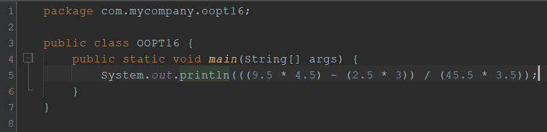

## Exercise 7

## Exercise 8

# Tutorial 2

## Exercise 1

## Exercise 2

## Exercise 3

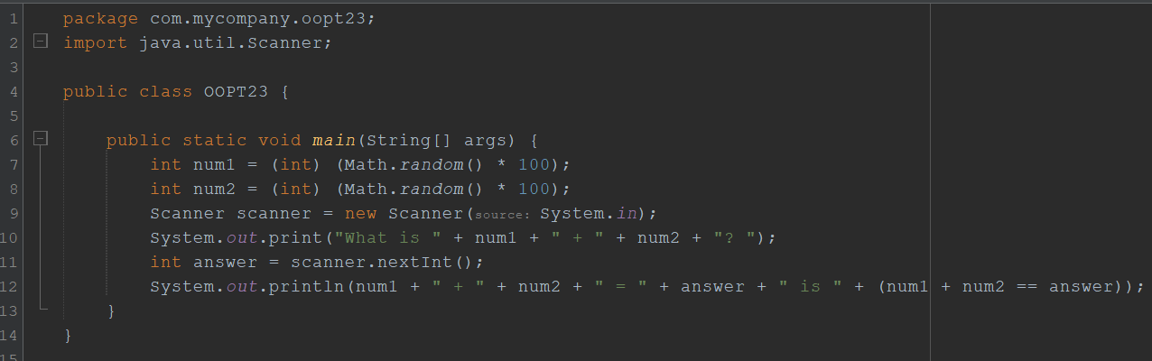

# Tutorial 3

## Exercise 1

## Exercise 2

## Exercise 3

## Exercise 4

# Tutorial 4

## Exercise 1

## Exercise 2

## Exercise 3

## Exercise 4

## Exercise 5

